10/3/2019

User Document

Licence Solution



[I.S Ngobese](http://linkedin.com/in/innocent-skhumbuzo-ngobese-5697a6129)

Table of Contents

A. System Summary 2

1. User Access Levels 2

2. System Configuration 2

3. Validation 2

B. Getting Started 3

1. System Navigation representations/Actions 3

2. Logging On 3

3. System Menu 4

# System Summary

The user will capture the information into the system and then the system must be able to keep records and notify via **email [and sms] (which will come at a later stage)** when the licence is about to expiry. All the information captured will be accessible/viewable in the system, editable and permanently removable if required.

## User Access Levels

* Administrator
  + Can access everything and anything from the system
  + Can set the application configurations
  + Can add/remove User
  + Can add/remove Association
  + Is the only user that can permanently delete something on the system
* Association Clerk/Owner
  + Can add new, view and edit existing Licences

## System Configuration

* The administrator needs to add the ***Association(s)*** that will be using the system into the system (This is important as the associations are used when registering a new user, to assign the user to the specific Association and when adding the Owner, it also has to be assigned to a specific Association)
* The Administrator needs to ***Configure*** ***Time*** to send notifications. 0**9:00am** is set as default. N.B. Time should be set in ***24hour******format***

## Validation

* ID Number: should be a valid RSA ID Number
* No special characters are accepted i.e. (*/#@%$ etc.)
* The application will show Message in red text if there is any business rule violation

# Getting Started

## System Navigation representations/Actions

* +  List button used to navigate back/to a certain list/table view
  +  Add New button used to create new record of a specific licence
  +  Details button used to show more information on certain record
  + Edit button used to edit information on a specific record
  + Delete button used to delete a specific record
    -  Delete button used to confirm to permanently delete a specific information
  +  Search box is used to search and filter on a specific record/records from the list/table by any field/column available on the list/table
  + 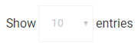 Used to filter the list/table to show selected number of rows
    - 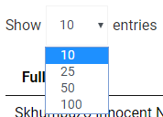 By selecting number from the dropdown, the list/table will show only that number of records if it has more than the number selected records: e.g. selecting 25 will show only 25 records from the list if there is more than 25 entries available.

## Logging On

* An administrator registers a user and the user gets an email with Username and Password.
* N.B. The user needs to confirm the email by ***clicking on the link*** on the email sent with the username and password to be able to log on.
* A username (email address) and password is required to log onto the application.

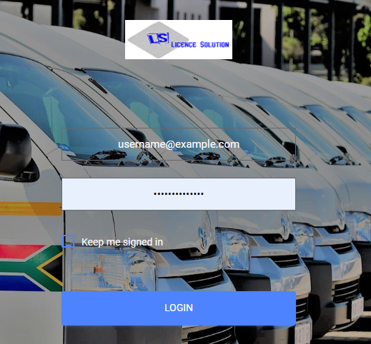

## System Menu

* + Dashboard
* A home page:

Which has Option Menus to add new data into the system:-



Also shows charts for:

* Licences expiring in 3 months or less:
  + - * By hovering on to each section as per colour codes at the top of the chart, it will show number of licences expiring as per that licence type

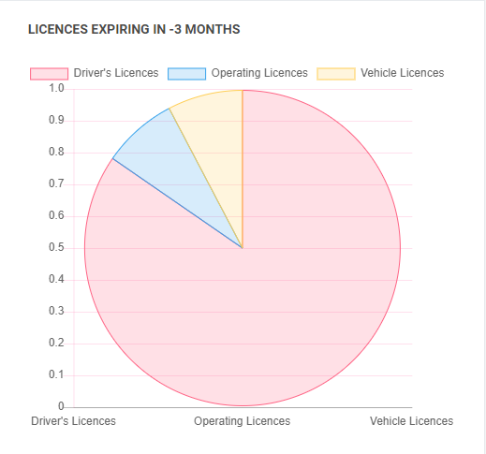

* Total number of licences:
  + This chart shows a total number of Licences as per association, including the valid, the ones about to expire and invalid ones.

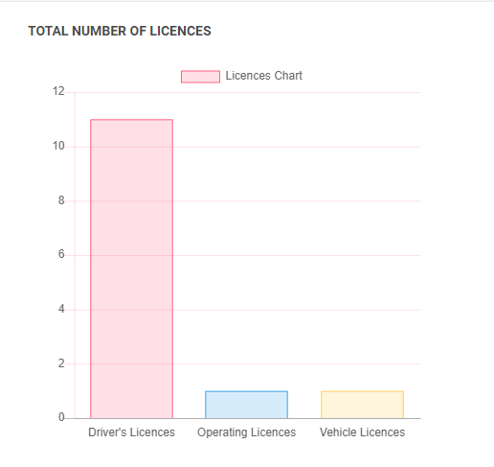

* + Associations
    - View List of Associations

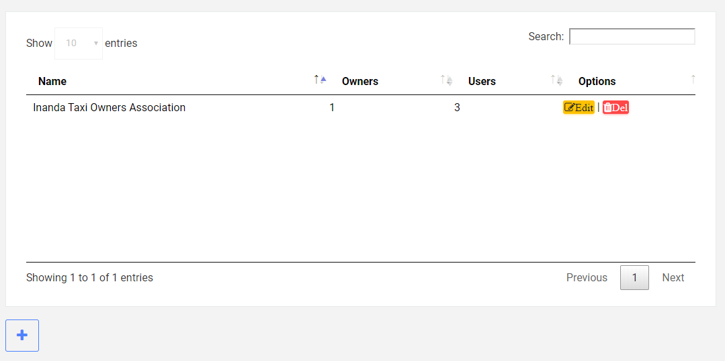

* Owners
  + - View List of Owners

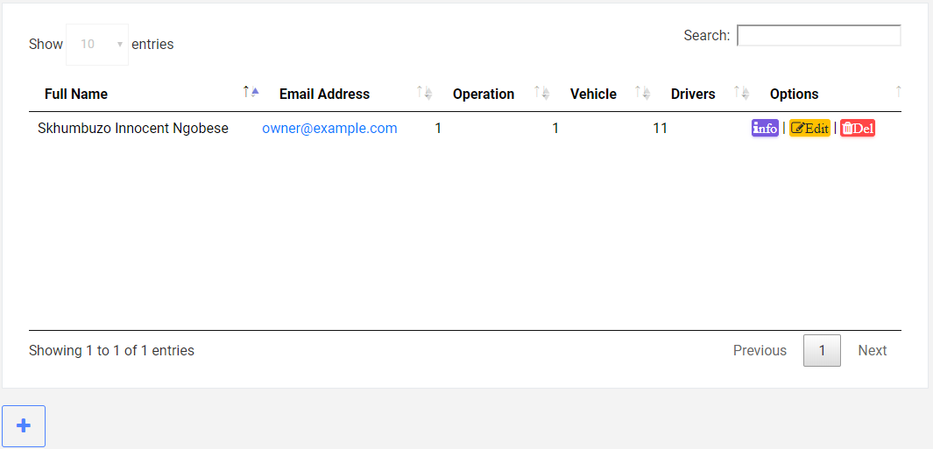

* Driver’s Licences
  + View List of Driver’s Licences

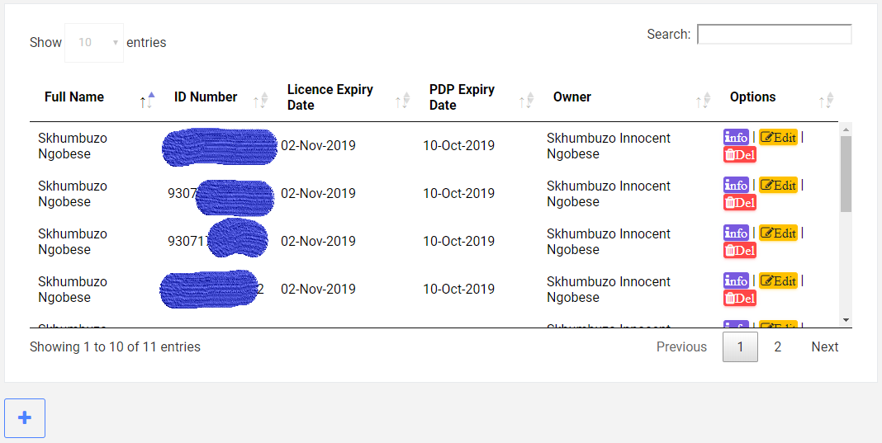

* Operating Licences
  + View List of Operating Licences

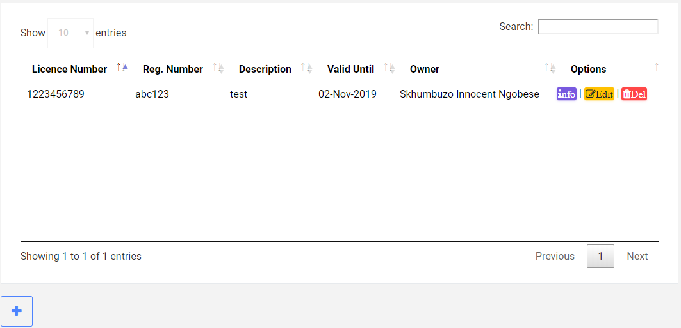

* Vehicle Licences
  + View List of Vehicle Licences

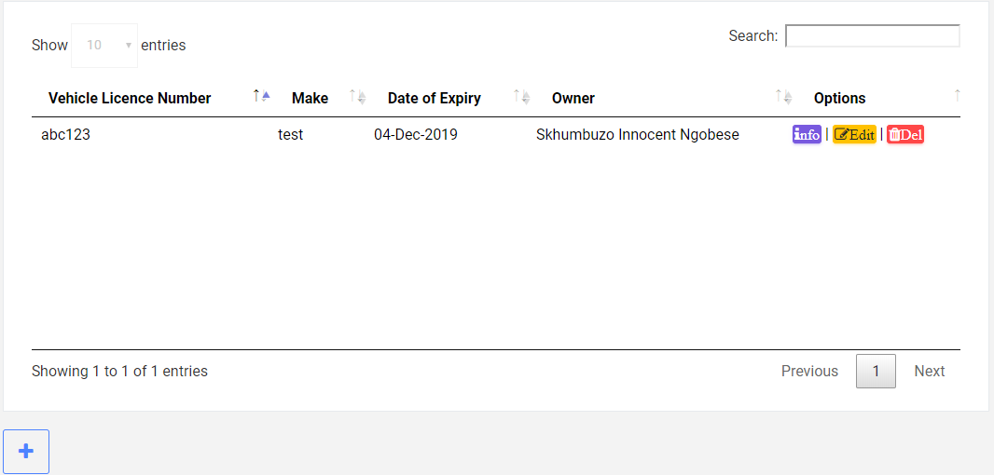

* Register User
  + Register a new user
    - A role selected determines which level the user is going to be as per User Access Levels
    - Username has to be an Email Address
    - Username must be unique
    - Password must be at least 6 characters
    - Password must include at least 1 digit/number
    - Password must have at least 1 uppercase character
    - Password must have at least 1 lowercase character
    - Password must have at least one special character
  + After user registration, an email containing **username and password** set is sent to the email address specified as user’s username
* Configs
  + Time set on “Configs” is the time the application is going to send notifications on when the licences are about to expire.
    - You can change the default time by clicking 
    - N.B. The time must be in 24hour format e.g. 09:00, 09:30, 14:10, 17:01 etc.
* Settings
  + User can manage their Account

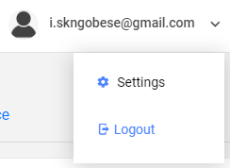

* Edit **Profile** details like Title, First Name, Middle Name, Last Name, Email Address and Phone Number and Save by clicking when done changing
* Change **Password**
* Activate **Two-Factor Authentication**
* Download/Delete **Personal Data**
* View/Delete all application users
* Return to Home Page by clicking on 
* Logout from the application
  + By clicking expanding the dropdown with the username and clicking “Logout”

